Homework 4

**Feed Forward Tasks:**

**Graph of loss curve for 5 different learning rates**

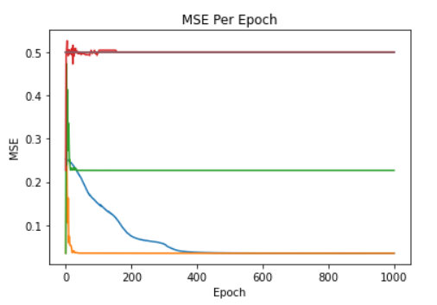

Learning rates used: 0.03 (original), 0.09, 0.27, 0.81, 0.01, and 0.0033.

**Graph of loss curve for 5 different numbers of hidden nodes**

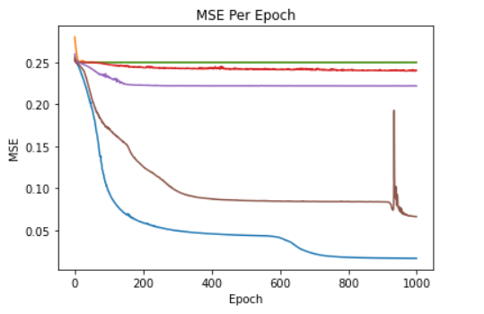

Hidden state value: 1, 2, 4, 8, 12, and 16 (original). From testing, twelve seemed to be the lowest state value you could use before learning became really poor (and even here it becomes weird towards the end).

**Graph of loss curve with an additional layer**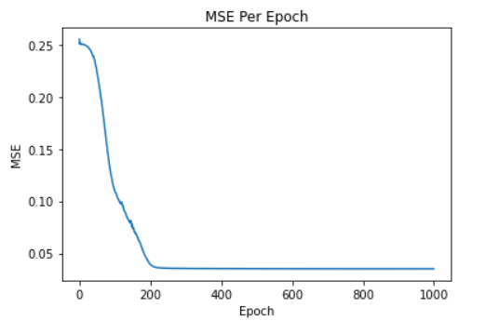

**RNN Tasks:**

**RNN Loss Curve**

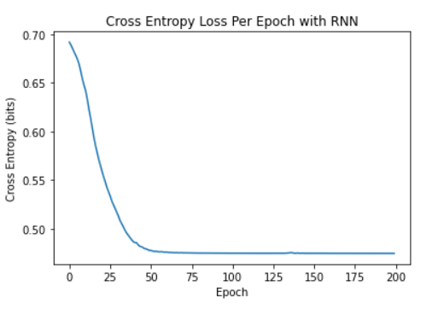

**RNN Classification of 5 Different Length Sequences**

